MID SEM PRACTICAL EXAM SUBJECT- JAVA Programming (PMC-

NAME-Garima Bisht SEM-2 COURSE-MCA CAMPUS- Haldwani

STUDENT ID- 20712004 UNIVERSITY ROLL NO-2098004

/\*

Answer1

Garima Bisht

\*/

import java.util.\*;

class Intermediate

{

public static void main(String args[])

{

String original, reverse = "";

Scanner in = new Scanner(System.in);

System.out.println("Enter a string to reverse");

original = in.nextLine();

int length = original.length();

for (int i = length - 1 ; i >= 0 ; i--)

reverse = reverse + original.charAt(i);

System.out.println("Reverse of the string: " + reverse);

}

}

Output

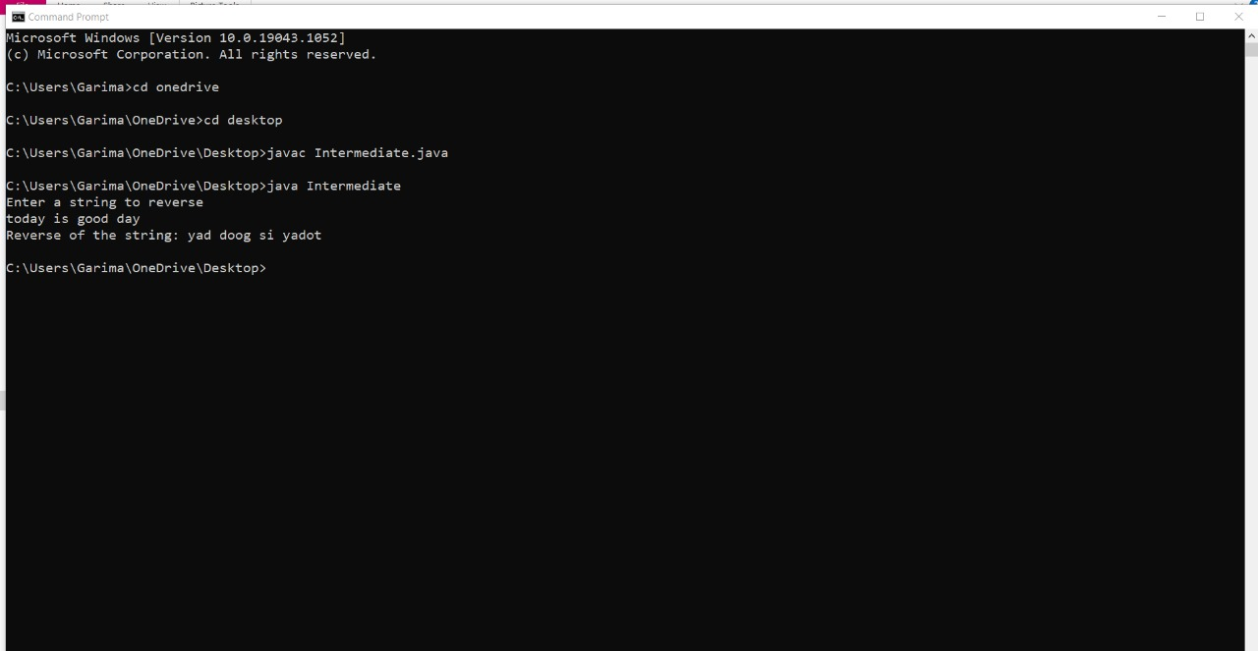

/\*

Answer2

Garima Bisht

\*/

import java.io.\*;

import java.lang.\*;

class LessBalanceException extends Exception

{

LessBalanceException(double amt)

{

System.out.println("Withdrawing "+amt+" is invlaid");

}

}

class Account

{

static int count=0;

int accno;

double bal;

String name;

Account(double bal,String n,int accno)

{

System.out.println("\nNew Account opened....!!");

this.bal=bal;

count++;

System.out.println("Account Holder Name : " + n);

name=n;

System.out.println("Your Account Number is : "+accno);

this.accno=accno;

System.out.println("Total number of accounts : "+count);

}

void deposit(double amt)

{

System.out.println("Availabe Balance : "+bal);

bal=bal+amt;

System.out.println("Rs. : "+amt+" /- Created");

System.out.println("Balance : "+bal);

}

void withdraw(double amt) throws LessBalanceException

{

System.out.println("\nAvailabe Balance : "+bal);

bal-=amt;

if(bal<500)

{

bal+=amt;

throw new LessBalanceException(amt);

}

System.out.println("Rs. : "+amt+ "/-Debited");

System.out.println("Balacne : "+bal);

}

void balance()

{

System.out.println("\n\*\*\*\*\*\*Customer information\*\*\*\*\*");

System.out.println("============================================");

System.out.println("Customer Name : "+name);

System.out.println("Account Number : "+accno);

System.out.println("Balance : "+bal);

}

}

class AccountDupli

{

static int i=0;

public static void main(String argv[]) throws IOException

{

Account ob[]=new Account[10];

BufferedReader br=new BufferedReader(new InputStreamReader(System.in));

double amt;

String name;

int ch,accno,k;

boolean t=false;

while(true)

{

System.out.println("\n\*\*\* Bank Transaction \*\*\*");

System.out.println("1.Open new Account\n2.Deposit");

System.out.println("3.Withdraw\n4.Balance\n5.Exit");

System.out.print("Enter your choice : ");

ch=Integer.parseInt(br.readLine());

switch(ch)

{

case 1:

System.out.println("Opening New Account : ");

System.out.print("Enter your name : ");

name=br.readLine();

System.out.print("\nEnter Account Number : ");

accno=Integer.parseInt(br.readLine());

System.out.print("\nEnter initial amount(to be >=500) : ");

amt=Double.parseDouble(br.readLine());

if(amt<500)

System.out.println("You cannot create an account with less than Rs.500/-");

else

{

ob[i]=new Account(amt,name,accno);

i++;

}

break;

case 2:

System.out.print("\nEnter Account number : ");

accno=Integer.parseInt(br.readLine());

for(k=0;k<i;k++)

if(accno==ob[k].accno)

{

t=true;

break;

}

if(t)

{

System.out.print("\nEnter the Amount for Deposit : ");

amt=Double.parseDouble(br.readLine());

ob[k].deposit(amt);

}

else

System.out.println("Invalid Account Number...!!!");

t=false;

break;

case 3:

System.out.print("\nEnter Account number : ");

accno=Integer.parseInt(br.readLine());

for(k=0;k<i;k++)

if(accno==ob[k].accno)

{

t=true;

break;

}

if(t)

{

System.out.print("\nEnter the Amount for Withdraw : ");

amt=Double.parseDouble(br.readLine());

try

{

ob[k].withdraw(amt);

}

catch(LessBalanceException e)

{}

}

else

System.out.println("Invalid Account Number...!!!");

t=false;

break;

case 4:

System.out.print("\nEnter Account number : ");

accno=Integer.parseInt(br.readLine());

for(k=0;k<i;k++)

if(accno==ob[k].accno)

{

t=true;

break;

}

if(t)

{

//System.out.println(accno +" asdfsdf " +ob[k].accno);

ob[k].balance();

}

else

System.out.println("Invalid Account Number...!!!");

t=false;

break;

case 5:

System.exit(1);

default: System.out.println("Invalid Choice !!!");

}

}

}

}

Output

